Question 1

hey from message 1

Question 2

Hey from massage 1

Hey from massage 2

Question 3

Hey from massage 1

Hey from massage 3

Hey from massage 2

Question 4

Hey from massage 1

Hey from main controller

Hey from massage 3

Hey from massage 2

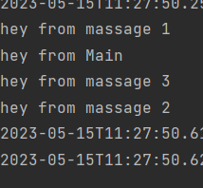

Question 5

Hey from massage 3

Hey from massage 2

Hey from main controller

Hey from massage 1

